Riparian Assessment Data Sheet

Project location |  | Site number
Date |  | Scribe name
Latitude |  | Longitude
Reference point details
Canopy (%) | Ground Cover (%) | Weeds in canopy (%) | Weeds in Ground Cover (%)
Main species observed
Additional Comments

Instructions
Think about what and why you want to monitor. Have you been undertaking planting following fires and want to track outcomes? Is there an area in decline? Choose your sampling site(s) accordingly. The site(s) need to be safe to access, and if it is on private property, make sure you have the permission of the landholder. You also need to undertake a risk assessment and do a safety briefing with anyone attending. A risk assessment has been attached to the end of this document. Please add to it accordingly or create your own.

To avoid paper waste, please just print page one of this document (making as many copies as you have sites), and keep these instructions as a digital copy.

You will need:
- A GPS (if available);
- The datasheet, a clipboard and pencils;
- Appropriate PPE such as enclosed shoes, long pants, and a hat;
- Water;
- First aid equipment; and
- A mobile phone with a camera.

If you want to come back over time, mark your site(s) using a GSP (if available) or a clear reference point such as a boulder or building.

At each sampling site, identify the riparian zone. The riparian zone is the area from the water's edge to where the stream still influences the type and density of the bank-side vegetation. Visually estimate the percentage area of the riparian zone covered by plants and what percent you estimate as weeds. You need to do this for both the canopy (treetops) and ground cover. Add this information to your datasheet. See the figures below for how to determine the appropriate percentage.

Provide information about the main species observed and any other additional comments. If your plant ID skills need some help, Landcare, Local Land Services, National Parks etc., should have resources with images of common native and weed species in your area.

After recording, take a photo of your datasheet. This way, if you lose the sheet, you still have your data.

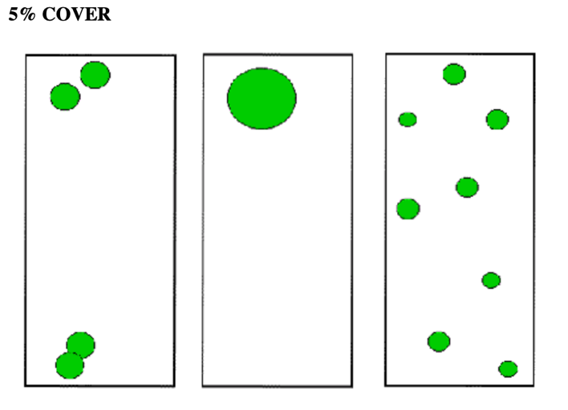
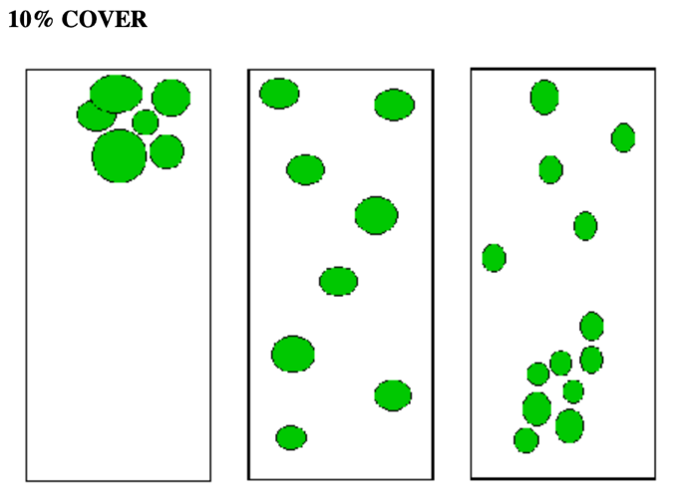
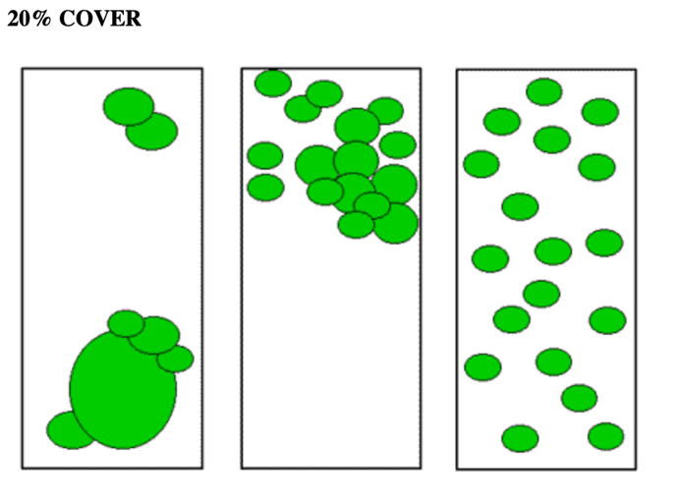
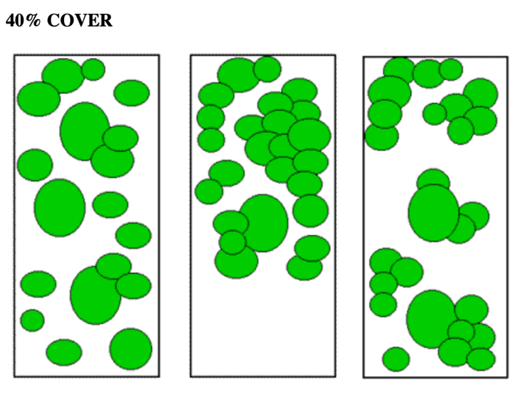
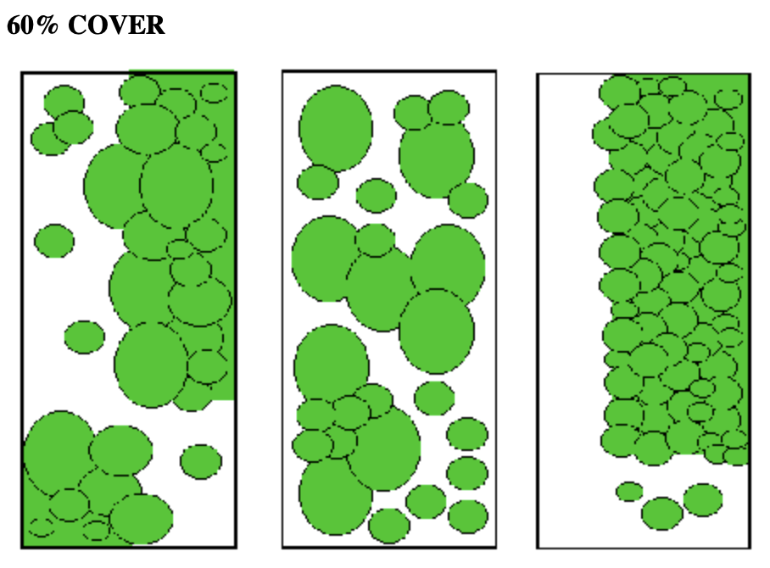
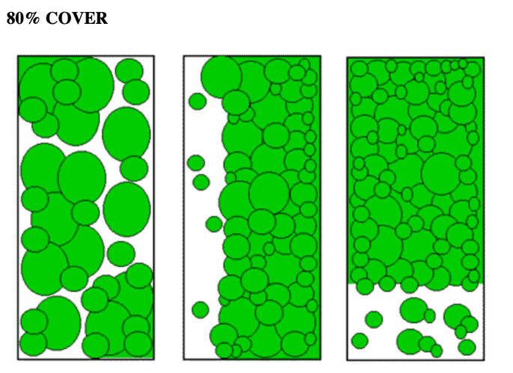

RISK ASSESSMENT
RA 2: HABITAT MAPPING AND FIELD WORK
ORGANISATION DETAILS
Organisation name: | OzFish Unlimited | ABN: | 29602568696
Prepared by: |  | Authorized by: |  | Telephone:
Position: |  | Position:
Signed: |  | Signature:
Date: |  | Date:
SITE SPECIFIC INFORMATION
Project Name |  | Area/Location/Address
Project Date/s |  | Comments
Manager |  | Supervisor
Contact Number |  | Mobile Number
This RA is submitted to (Principal Contractor)
Company: |  | Contact Name:
Signature: |  | Date:
Emergencies: | In the event of an incident or emergency, follow the instructions provided during the Site Specific Induction. All incidents must be reported to your Supervisor. If required the site Supervisor will contact the emergency services on 000 or 112.  If requested to evacuate the site, you must do so immediately and gather at the designated site assembly point.

Instruction for use: Tick boxes by hand, or bold and highlight item

List plant, equipment, tools to be used
- Display boards | - Table | - Witches hats | - Banner | - Info fact sheets | - Hand tools
- Marquee | - Chair/s | - Rope | - OZFISH UNLIMITED Collateral | - Activity resources | - Plants
- Drinking water | - Cool Box | - Binoculars |  |  | - Watering can/s
 |  |  |  |  | - Hose
List hazardous substances to be used or handled
 | - MSDS read & understood |  | - MSDS read & understood |  | - MSDS read & understood
List of PPE
- Hard Hat | - High Vis clothing | - Hearing protection | - Protective Visor | - Long sleeves & trousers | - Sun Hat
- Safety Boots | - Gloves | - Safety Glasses | - Dust mask/respirator | - Disposable overalls | - UV Cream
- Harness | - Uniform shirt | - Uniform polo | - Wet weather jacket | - Wet weather pants
Fire & Emergency Equipment
- First Aid Kit Type B (over 10 people/remote area) | - Satellite Phone | - Fire Blanket | - Hazard signs
- First Aid Kit C (under 10 people) | - Fire extinguisher | - Snake Bight Kit | - Mobile phone
Training/Certification required
- RA General Induction Card (White Card) | - First Aid Certificate | - Site Specific Induction | - 4WD training | - Chainsaw License
- Remote Area First Aid Certificate | - Senior First Aid Certificate | - Chem Cert | - Drivers License | - Working at height
Minimum number of employees to safely supervise event/complete task/s |  | - 1 | - 2 | - 3 | - 4
Legislation, codes of practice, standards applicable to this RA |  | www.workcover.nsw.gov.au/ WHS Act 2011 – WHS Regulation 2011;  www.workcover.nsw.gov.au/ WC00231_Writing Work Method Statements in Plain English  www.workcover.nsw.gov.au/ Documents/how-manage-work-health-safety-risks-code-of-practice-3565.

Health & Safety Risk Level Matrix
 | Consequences
Likelihood | Insignificant  Minor injury requiring first aid but no lost time or a few incidents which do not result in injury | Minor  Single injury requiring medical treatment resulting in some lost time or a large number of incidents resulting in minor injuries | Moderate  Single serious injury or illness requiring hospitalisation and rehabilitation due to a single cause at one location | Major  Single fatality, multiple injuries or major incapacity or series of single fatalities or major injuries due to a single cause at one location | Catastrophic  Multiple deaths from a single event or serial deaths over one year or cumulative and delayed disability due to a single cause at one location
Almost certain  Likely to occur about once a month | H | H | E | E | E
Likely  Expected to occur once every year | M | M | H | E | E
Possible  Will be Expected to occur once every 10 years | L | M | M | H | E
Unlikely  Will be expected to occur once every 100 years | L | L | M | H | E
Rare  Will be expected to occur once every 1000 years or less | L | L | M | H | H

Level of Risk

E: Extreme risk; immediate action required

H: High risk; senior management attention needed

M: Moderate risk; management responsibility must be specified
L: Low risk; manage by routine procedures

RISK ASSESSMENT – WETLAND ASSESSMENT AND FIELD WORK
Item | Job Step  Break the job down into steps. | Potential Hazard  What can harm you? | Risk  Level | Controls  What you are going to do to make the job as safe as reasonably practicable? | Remaining Risk Level | Person responsible
 | Traveling to and from site | Vehicle accident, breakdown | E | - See RA4 Motor Vehicles  - Park Vehicle on site facing exit  - Adhere to Federal and state road legislation  - All drivers must have necessary licences  - A spotter should be used to assist with directions when reversing or 4WDing in difficult conditions or poor visibility | M | All staff, volunteers
 | Entering and leaving the site | Unauthorised entry, unknown dangers, unrequired search | H | - Seek permission from land owner/manager and notify them prior to entering the site.  - Request briefing on any site specific hazards  - Leave gates as found, stay on agreed tracks and areas  - Notify owner when leaving the site | L | Field Supervisor
 | Field Work General | Unknown injured or lost, unrequired search | H | - Fill out staff booking sheet, Call / advise office with location & site phone number, advise primary contact person  - Notify contact person on return | M | Field Supervisor
 | Field Work General | Sun exposure Sunburn Sunstroke Dehydration | M | - Wear long sleeved shirts with collars, long pants, broad-rimmed hat, sunglasses  - Have sunscreen available  - Make use of available shade  - Drinking water provided  - Take rest breaks and / or work in shade  - Avoid working in the hottest part of the day, leave site early, or postpone work in extreme conditions | L | All staff, volunteers
 | Field Work General | Cold weather | L | - Don't work in wet cold weather  - Wear rain jackets and rain pants as necessary  - Wear appropriate warm clothing  - Bring spare set of clothes / socks on potentially wet days | L | All staff, volunteers
 | Field Work General | Physical hazards | H | - Do not use faulty equipment  - Keep site tidy and don't leave tools in access ways  - Put tools in one spot when finished (identified by supervisor)  - Use tongs and suitable sharps containers  - Wear appropriate PPE (Personal Protection Equipment)  - Use equipment authorised by supervisor | L | All staff, volunteers
 | Field Work General | Fencing, holes, drains, stumps, cattle, horses, bushland, & biological hazard | H | - Site induction and risk assessment by site supervisor | L | All staff, volunteers
 | Field Work General | Crocodiles | E | - Site induction and risk assessment by site supervisor  - Contact land management authority and ask about crocodile locations and activity and safety protocols.  - Observe warning signs.  - Stay alert at all times.  - Look for signs of crocodiles: wallows, slides, nests.  - Keep a minimum of 50 metres between you and your boat and crocodiles.  - Make sure your boat motor is in good running order – see RA5 Working in Water.  - Be aware crocodile activity increases with temperature. In crocodile territory it is preferable to work in winter. | H | All staff, volunteers
 | Field Work General | Topography | H | - Site induction and risk assessment by site supervisor  - Maintain clear access  - Flag off danger zones  - Create and use safe access trails  - Avoid slippery edges and rocks  - Risk assessment taken for non-swimmers  - Do not run on site  - Be aware of and locate hazardous branch falls  - Observe on-site safety: consideration for oneself and others | L | All staff, volunteers
 | Field Work General | Fire hazards | E | - Site induction and risk assessment by site supervisor  - Always park vehicle facing the exit to the bushland  - Risk assessment by supervisor on medium to high fire risk days  - Fire hazard awareness in isolated situations  - Hypothetical fire drill covering exits in all directions  - Maintain tidy worksite to reduce fuel loads, e.g. small weed piles  - Keep fuel away from flames  - No smoking near petrol or other flammable materials  - Ensure cigarette butts are extinguished, collected and removed from site | M | All staff, volunteers
 | Field Work General | Manual Handling | H | - See RA3 Manual Handling | M | All staff, volunteers
 | Field Work General | Water Hazards | H | - Follow procedures in RA5 Working in water  - Check waterway for signs of contamination  - Ensure waders or gum-boots are watertight  - Continually assess area for signs of submerged objects and to determine likely depth  - Proceed slowly in all areas  - Monitor water and body temperature and avoid hypothermia. | M | All staff, volunteers
 | Field Work General | Electrical and mechanical hazards | H | - Follow procedures in OZFISH UNLIMITED RA Policy  - Check electrical equipment for worn / cut cables  - Check placement of electrical equipment to avoid water contact  - Earth leakage circuit breakers must be used in all outdoor workplaces  - Check equipment is in good working order – do not use faulty equipment under any circumstance  - Report faults / hazards to site supervisor  - Use PPE  - Ensure all guards are in place  - Undertake OH & S training  - Work safely when doing any mechanical or electrical operations, e.g. be aware of yourself and others when swinging a mattock  - All equipment must be tested and displayed with a valid tag  - Training will be given before use | L | All staff, volunteers
 | Field Work General | Hazardous materials / pesticides | H | - Follow procedures in OZFISH UNLIMITED RA Policy and RA7 Cut and Paint weed treatment.  - Follow and familiarise yourself with MSDS instructions  - You must not use chemicals unless qualified (Australian Licence Standard)  - Store all chemicals and contaminated containers in the sealed containers in the work vehicle – do not store hazardous materials together  - Water provided in the work vehicle maintained  - Display signage where necessary  - Water must be safely available  - Understand Duty of Care to yourself and others | M | All staff, volunteers
 | Field Work General | Plants & Wildlife | L | - Site induction by supervisor  - Wear suitable work clothing and PPE when working near to or collecting from spiny or thorny plants  - Be aware of first aid kit location  - Be aware of wildlife and take measures to reduce contact with dangerous species, e.g. tread loudly to scare off snakes, look for funnel webs when moving mulch, etc.  - You may also encounter paper wasps, bees, ticks, spiders, ants, mosquitoes, sandflies, leeches, etc.  - Check and remove leeches and ticks during breaks and on completion of field work.  - Treat bites with an antiseptic, take anti-allergy tablets under your pharmacists supervision if required.  - Insect repellent will be supplied | L | All staff, volunteers
 | Field Work General | Drugs & Alcohol | M | - Follow procedure in OZFISH UNLIMITED RA Policy  - Strictly prohibited during work hours and in breaks  - Must report to work with 0.0 alcohol blood level and drug free | L | All staff, volunteers
 | Field Work General | Smoking | H | - Follow procedure in OZFISH UNLIMITED RA Policy  - No smoking within 20 metres of others, or in and around vehicles  - Cigarettes butts must be extinguished entirely, secured in a sealed container, and taken off site for disposal | L | All staff, volunteers
 | Field Work General | Behaviour | M | - Harassment, discrimination, disruptive negative behaviour will not be tolerated | L | All staff, volunteers
 | Field Work General | General Chemical Handling | M | - Refer to RA 7 Chemical Hand Application  - If spraying, prepare and train with a RA and ensure operator has compliant chem cert training. | M | All staff, volunteers
 | Weeding | Environmental degradation | H | - Refer to RA 6. Physical Weed Removal  - Leave plant if it can't be correctly identified by reference manual or supervisor  - Record weed  - Follow supervisor instructions on weed removal techniques – if unsure of technical method, ask supervisor  - Training will be given by the supervisor for all new tasks performed  - Do not leave large areas of exposed soil in highly erodible situations to reduce silt load entering waterways  - Allow enough vegetation for habitat and environmental protection of ecosystem (e.g. reduce over-exposure from sun)  - Pile or store weeded material so as to prevent reinfestation e.g. large-rooted lantana ends hung in tree  - Remove / bag appropriate part of the species which can lead to reestablishment of that weed species  - Let natural regenerator dictate rate of weed removal  - Work from least infested to most infested areas  - Cut and paint in erodible situations to reduce soil erosion | L | All staff, volunteers

Record of Job Safety Briefing
HABITAT MAPPING & FIELD WORK

Location: Date:

Supervisor/presenter:
RA’s covered:
Persons Present at Brief
Print Name | Signature |  | Medical Condition to report?  Signature
Issues raised by staff/volunteers/participants
Corrective Action |  | Action by |  | Action Complete
 |  |  |  | Sign off | Date

